Jose Berlingeri, jberlingeri3, Section A

Victor Rohlfs, vrohlfs3, Section A

Rohith Ravi, rravi6, Section A

Brian Cai, GT bcai7, Section A

[37]

[Phase 1]

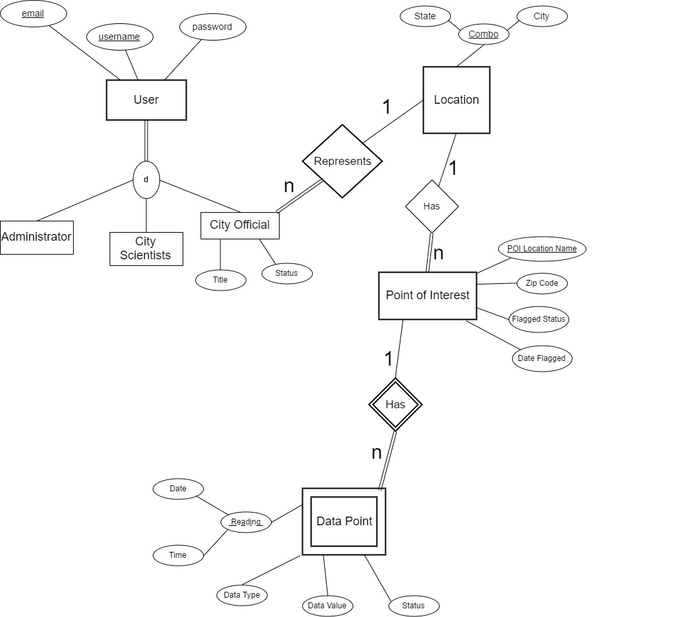EER Diagram:

U

U

U

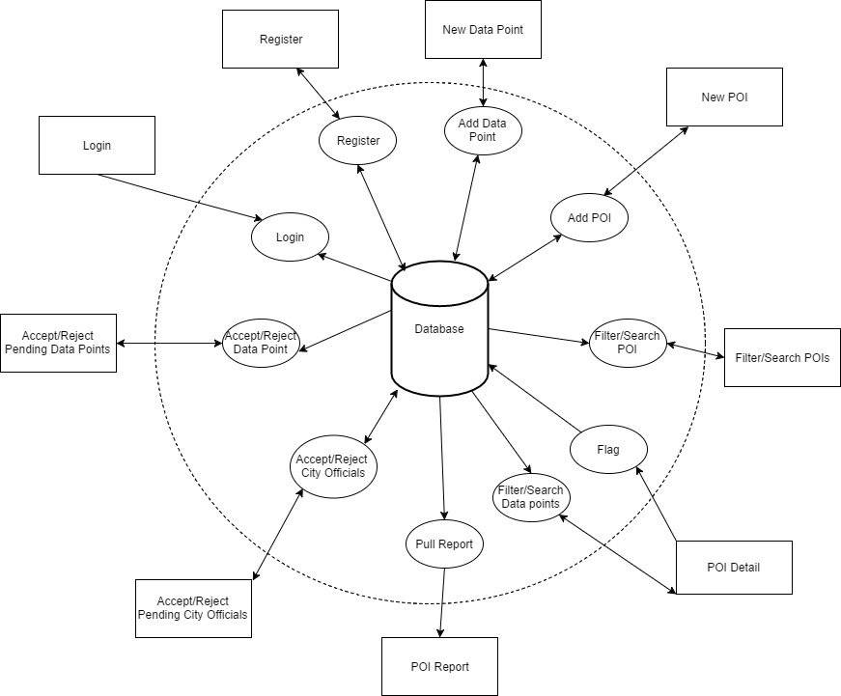Information Flow Diagram:

Logical Constraints:

* When a City Official registers, their **Status** attribute is automatically set to “pending”
* When a Data Point is added, its **Status** attribute is automatically set to “pending”
* If a Point of Interest’s **Flagged Status** attribute is True, then its **Date Flagged** must not be Null
* If a Point of Interest’s **Flagged Status** attribute is False, then its **Date Flagged** must be Null

Assumptions:

* When a City Official flags a Point of Interest, **Date Flagged** is populated with the current date.
* The Database is pre-populated with all of the Cities and States (satisfies drop down menu feature)
* The Database is pre-populated with the Data Types (mold reading and quality reading) for the Data Points
* The 3 different User types are saved in the database for the registration window